**READING STAGE 6**

<__question>

**Minimum – Water Gardens**

We usually think of gardens as lush, well-planned, well-watered areas with rich loamy soil. This is not always so. There is a growing interest in another type of garden - the ‘dry’ garden. The Japanese have always had their seki tei - sand and stone gardens. These walled gardens are often used for prayer by Buddhist monks. Sand and rocks symbolically arranged are the key elements in these gardens.

Cactus gardens in the more arid regions require little maintenance. The biggest killer is too much love, too much water or too much fertilizer. Cacti (plural of cactus) are succulents with spine cushions called areoles that can bear spines and/or flowers but the plants do not have branches or leaves. A succulent is a juice - or sap-storing plant. Succulents have evolved to grow in harsh conditions. They store water for future use.

The soil of a cacti garden is about one-third sand, one-third ‘dirt’and one-third gravel. Using rocks in these gardens is in keeping with how cacti would look in the dessert where rocks may be common. A cacti garden has to be well drained.

The Royal Botanic Gardens in Cranbourne, Victoria, has developed a series of dry-garden environments to demonstrate not only the diversity of Australian flora but to put Australian plants into cultural context.

Visitors can walk through the Red Sand Garden where the expanse of red sand contrasts with grey foliage. On the northern hill of this garden, mass plantings of *Acacia binervia* and the *Spinifex sericeus* are used to stabilise the sandhills. The lower slopes are covered with a carpet of shrubs *Kunzea pomifera*, producing edible berries used for food by the Aborigines.

A second garden is the Dry River Bed, which relates to the fleeting nature of water within the Australian landscape. and the power of water to shape the land into riverbeds, on a seasonal basis. The central landscape of Australia is characterized by large river systems that can be located beneath the land surface, as part of the artesian water supply. On the surface, the plants respond by growing in the bars of sand that are shaped into curved lines along often-dry riverbeds.

A third garden is the Arid Garden. It has trees used sparingly, yet accurately representing the whole continent. Beneath are the lower species, such as Hedge Salt-bush, Sword-sedge, Fan-flowers, Bluebush, Poverty Bush and many types of daisies. The seasonal flower displays bring colours to this dessert landscape.

Population growth has increased demands on water in times of lower rainfall and dwindling supplies. It is time for gardeners to consider drier gardens rather than gardens dependent upon a high water consumption. A dry garden can be just as attractive and interesting, and more environmentally friendly.

Source : Royal Botanic Gardens Cranbourne, [www.rbg.vic.gov.au](http://www.rbg.vic.gov.au)

<__block>

The writer is ?  
[A] encouraging gardeners to think about gardens that are drought tolerant  
[B] advising gardeners in arid regions on what to grow

[C] imploring gardeners to plant more succulent-type plants

[D]asking gardeners to reduce the size of their gardens

<__block>

[A]

<__block>

What would be an important reason for having the cacti

(as shown in the photograph below ) in a raised bed ?

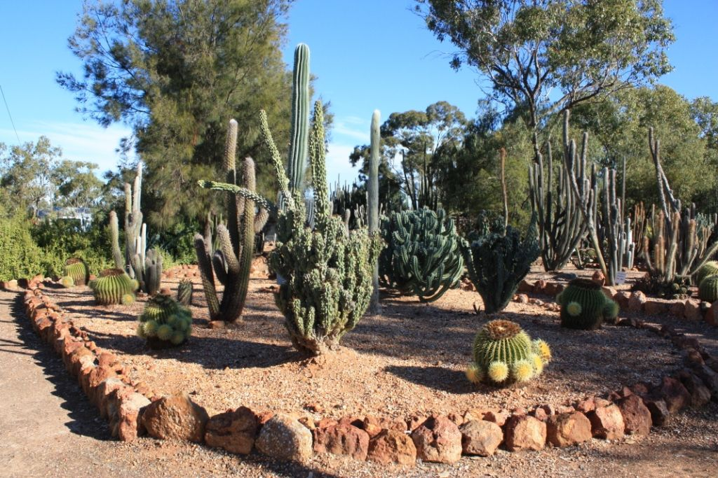

[A] it allows for comfortable maintenance

[B] it adds to the visual appeal of the garden  
[C] it assists in drainage  
[D] it prevents the growth of lush weeds

<__block>

[C]

<__block>

According to the text, which type of garden is often subjected to irregular water supplies ?  
[A] botanic gardens

[B] cacti gardens  
[C] Japanese sand and stone gardens

[D] dry riverbed gardens

<__block>

[D]

<__block>

‘Dry gardens’ are becoming increasingly relevant, not only because of climate change, but because of ?  
[A] increased population

[B] households using more water per capita  
[C] people making larger gardens

[D] less people living on suburban blocks

<__block>

[A]

<__block>

An important purpose of the Royal Botanic Gardens ( Cranbourne) is to ?

[A] provide visitors with a fun day out

[B] show people who live in arid areas how to have a garden  
[C] convince residents from Cranbourne (Vic.) area to change their gardening attitudes  
[D] display the wide range of Australian plants and their habitats

<__block>

[D]

<__block>

The ‘seki tei’-type of garden is designed to ?  
[A] maximise water use

[B] create a feeling of peace  
[C] improve the look of  temples

[D] make use of available stones

<__block>

[B]

<__block>

Which of these gardens, mentioned in the passage, could be called a traditional garden ?

[A] the Red Sand Garden

[B] the Japanese seki tei  
[C] the Arid Garden

[D] the Cacti Garden

<__block>

[B]

<__block>

The Dry River Bed Garden is designed with curved lines to ?  
[A] minimise the need for watering  
[B] add an attractive feature to the garden

[C] replicate the shape of inland rivers  
[D] take full advantage of any rainfall

<__block>

[C]

<__block>

What is a major problem faced by some cacti owners ?

[A] they require high maintenance

[B] succulents (or spine cushions) are dangerous  
[C] over watering

[D] the under watering

<__block>

[D]

<__block>

Which type of garden is **NOT** a minimum-water garden ?  
[A] dry river bed gardens  
[B] vegetable gardens

[C] arid gardens  
[D] cactus gardens

<__block>

[B]

<__question>

**So you want to be an actor?**

Many aspiring actors want to be on television or in a film. The truth is, a lot of the work is in commercials and corporate films (company training films) and these actually pay better.

As an actor, I started out as a ‘fifty-worder.’ This means that you may say anything from one to fifty words in the role. This is a step up from being an extra. Later I became a featured extra -which means you get to say a few words and a credit; your name, at the end of the television show. From there you can be given a guest appearance or even become a regular on the show.

There are few Australian actors that make a lifetime's living from acting. A few will make a living for several years from working on a soapie such as *Home and Away* or *Neighbours*, etc .Some will work as a major character in a long-running series, for example, *Homicide* and *Underbelly*. Others will concentrate on straight theatre (plays) or musical theatre.

Many young actors create their own work; writing plays or television shows, acting in them and producing them. Producing can mean anything from finding the money to put on a play or television show to finding the actors, directors, venues (places to perform) and getting anything required for the production.

In one low-budget film I was in, the producer found a backer (someone who was prepared to risk their money having the film made); wrote the film, directed it; found someone to feed the cast and crew; found assistant directors; make-up people, found locations - including a hospital that was being demolished the very next day; and an explosives expert to set the actors up to be ‘shot’. After shooting the film, he helped edit it (decide which parts to use and throw out) and then market (sell) it.

Paid work for actors is mainly centred on Sydney, Melbourne and the Gold Coast. This means that although there are greater opportunities, there is also more competition. So what does the aspiring professional do to get noticed?

Be professional. Turn up on time; know what you half to do; listen to what you are told; take direction, ie.. try to do what you are told by the director, be polite to everyone - you don't know how much influence they may have, remember that you may be in the centre of attention one day and almost ignored the next - it's the nature of the business; remember that it is business and treat it as such; be friendly to everyone; watch, listen and learn.

I once read that the different between an amateur and a professional is that an amateur learns their lines until they remember them whilst a professional learns them until they can't forget them. Partly true, but re-read the previous paragraph.

From Cygnet, Tasmania

<__block>

The best immediate money to be made is in commericials and ?  
[A] staged musicals

[B] soapies

 [C] corporate training films

[D] low-budget films

<__block>

[C]

<__block>

<__block>

Any person who backs a low-budget film could be described as a ?  
[A] film critic

[B] failed actor  
[C] shrewd investor

[D] gambler

<__block>

[D]

<__block>

What is the main disadvantage of looking for active work in major cities (Sydney, Melbourne and the Gold Coast }?

[A] There is more competition these places for the parts

[B] The cost of film production is high

[C] They are removed from where Australian films are recorded

[D] They are mainly the location for 'soapies'

<__block>

[A]

<__block>

To make a success of acting, John Andrews recommends that actor should ?  
[A] concentrate on straight theatre  
[B] treat acting as a business  
[C] enjoy acting as an interest and a pastime  
[D] attend professional acting classes

<__block>

[B]

<__block>

Which of the following best lists in order the typical career path of many (from beginner to established actor)?  
[A] extra, ‘fifty-worder’, featured extra, regular, guest appearance  
[B] featured extra, extra, ‘fifty-worder’, guest appearance, regular  
[C] regular, featured extra, extra, ‘fifty-worder’, guest appearance  
[D] extra, ‘fifty-worder’, featured extra, guest appearance, regular

<__block>

[D]

<__block>

Being a successful actor is not only knowing lines, but also ?  
[A] being prepared to write plays and scripts  
[B] helping out with editing films  
[C]  being polite to the people in the industry  
[D] ignoring much of what you are told

<__block>

[C]

<__block>

A feature low-budget films is ?  
[A] their high instant success rate  
[B] the number of roles the producer undertakes  
[C] the number of parts for aspiring actors  
[D] their good box-office returns

<__block>

[B]

<__block>

The general impression of professional acting implied by John Andrews is that it provides a lifestyle that is ?

[A] precarious but interesting

[B] financially rewarding and glamorous

[C] glamorous but poorly paid

[D] difficult and demanding

<__block>

[A]

<__question>

**Desert Dweller**

A lizard torpedoes the knotted terrain

its toes, webbed finely, splay

divining rock and searing sand.

It has a repertoire, dances with the land

A flamenco first and then the tango.

Sharp agate eyes reflect a flaming sun

And dressed in armour, waxed leather mail,

This jousting knight charges foes

A pre-determined destiny

Its weaponry an arsenal of muscle, sinew, instinct.

© 2007 Sheryl Persson

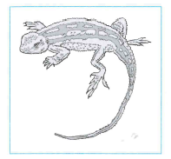

<__block>

The poet uses the word ‘torpedo’ to describe ?

[A] how strong the lizard is

[B] the size of the lizard

[C] how the lizard moves

[D] the length of the lizard

<__block>

[C]

<__block>

The word  'splay' is closest in meaning to ?

[A] spread apart

[B] curve outwards

[C] supports weight

[D] sway gently

<__block>

[A]

<__block>

The poet's description of the lizard's eyes as ‘agate eyes reflect a flaming sun’ suggests that the lizard is ?  
[A]  agile  
[B]  alert  
[C]  afraid  
[D]  able

<__block>

[B]

<__block>

Which of the following words from the poem refers to the lizard's skin ?

[A] knotted

[B] armour

[C] jousting

[D] sinew

<__block>

[B]

<__block>

Which of the following conclusions can be drawn from the poem ?  
[A]  The poet is fascinated by the features of the desert landscape  
[B] The poet is worried that the lizard is vulnerable to the enemies    
[C] The poet wonders how long the lizard can survive the harsh conditions  
[D]  The poet marvels at how the lizard had adapted to it's environment

<__block>

[D]

<__block>

Which technique does the poet employ most in the poem to create visual images of the  lizard ?  
[A] alliteration  
[B] symbolism  
[C] personification  
[D] simile  
<__block>

[C]

<__question>

Shane and his father (an ex policeman) are sleeping in a caravan in the yard of an abandoned school that Shane's father had just bought. Now read on.

**Cadaver Dog**

When Shane woke up during the night, he vaguely aware that he had been woken up by an alien noise. The dog growling? Someone calling? As his eyes became accustomed to the light he realized there was a faint glow coming in the window. At first he thought it was dawn. But there were no magpies warbling. There was a soft, indistinct crackling sound.

He thought he heard a muffled shout, or a cry.

Sleepily he turned over, it was then he noticed that the glow was not the steady glow of dawn but a flickering glow. It didn't make sense. When he looked out of his window he realized why.

The school was on fire!

The dog barked.

Grotesque shadows danced in the trees.

It took him a moment to react.

"Dad! The school's burning down! he cried out, suddenly fully awake.

He became aware of the roar of the flames as they turned from a bonfire into an inferno. In a moment his father was blundering around the caravan. A light went on. His father was fumbling with his mobile phone and swearing impatiently.

Caddy's barking grew angry, urgent.

From then on the action became a blur.

By the time the local bushfire brigade arrived the old school house was a little more than a large smouldering heap of burning timber and twisted corrugated iron.

Leaves in the nearby trees were scorched.

A nagging worry troubled Shane, as he and his father watched the firefighters complete the clean-up operations. Then they all stopped and congregated near a corner of the building.

They found something.

Caddy sat on her haunches near Shane's feet. She was whining nervously.

"Steady, girl," said Shane's father softly.

One fireman left the group and dashed for the truck. Within moments he was on the CB radio talking softly and urgently.

Then Shane suddenly realised why he was feeling uneasy, it wasn't the loss of the school - after all, it was on the ‘get rid of’ list. He gasped at the enormity of his realisation.

A person had died in the fire!

His father was looking at him. "You right?"

"Dad, I think..." For a moment Shane was lost for words. Then he blurted out his fears. With a deep sinking feeling he remembered the cry he had vaguely heard when he first woke up.

Shane's father was silent for a moment. Shane could almost imagine his father's detective mind putting pieces together. Looking for bits that would fit.

Another fireman was talking on a mobile phone.

By Alan Horsfield, Lothian Books (Crime Wave Series), 2000

<__block>

Shane was aroused from his sleep. What is the most likely reason for this ?  
[A] dog growling  
[B] a flickering light  
[C] magpies warblin  
[D]  a crackling sound

<__block>

[D]

<__block>

Shane complains of a ‘nagging worry’. A nagging worry is one that ?  
[A] irritates persistently because there is no obvious reason for the worry  
[B] has nothing to do with the present situation  
[C] is not as important as it seems  
[D] destructive and menacing

<__block>

[A]

<__block>

The speed of the fire was  ?

[A] predictable and impressive

[B] expected and frightening

[C] rapid and destructive

[D] destructive and menacing

<__block>

[C]

<__block>

The writer states ‘Grotesque shadow danced in the trees’. What does he mean by this ?  
[A] The shadows created by the fire flickered erratically in a disturbing way  
[B] The bush around the caravan was lit by the flames  
[C] The light cause moving shadows in the trees  
[D] People close to the fire had to move away quickly

<__block>

[A]

<__block>

Shane's father swore because ?  
[A] he couldn't find his light or his phone  
[B] he was being clumsy when he had to respond quickly  
[C] he didn't want the school to burn down  
[D] his mobile phone wasn't operating

<__block>

[B]

<__block>

What caused Shane to realize someone had died in the fire ?

[A] The fire fighters were making urgent calls

[B] The dog had begun to whine nervously

[C] He remembered hearing a cry

[D] Shane's father was looking for reasons for the cause of the fire

<__block>

[C]

<__block>

What was Shane’s fathers position in this story ?  
[A] security guard  
[B] policeman  
[C] land owner  
[D] his janitor

<__block>

[C]

<__block>

In the below list of events which occurred first ?

[A] the dog barks

[B] Shane’s father finds a light

[C] Shane becomes aware of an alien noise

[D] Shane's father calls the fire brigade

<__block>

[C]

<__block>

Caddy’s barking grew… ?  
[A] angry  
[B] frightened  
[C] nervous  
[D] defiant

<__block>

[A]

<__block>

How did Shane feel when he realized someone died in the fire ?

[A] nervous

[B] unable to react

[C] stunned by the enormity of the situation

[D] lost for words

<__block>

[D]

<__block>

What was Shane’s fathers position in this story ?  
[A] security guard  
[B] policeman  
[C] land owner  
[D] his janitor

<__block>

[C]

In the below list of events which occurred first ?

[A] the dog barks

[B] Shane’s father finds a light

[C] Shane becomes aware of an alien noise

[D] Shane's father calls the fire brigade

<__block>

[C]

<__question>

**Book Review : Facetime** (by Winnie Salamon)

By: Sally Murphy

Chat rooms, geeks, gnomes, b-grade movies - oh, and inflatable underwear.

When Esmerelda moves in with Charlotte, she's not sure if she's done the right thing. The two don't have much in common. Charlotte takes herself way too seriously and Esmerelda finds her intimidating and aloof.

Charlotte doesn't hit it off with Esmerelda's best friend Ned, either. Ned is a hardcore geek who wears flannies and Linux T-shirts and has no sense of style. He loves bad movies and trashy music. Esmerelda thinks he's great.

When Ned suggests Esmerelda try internet chat rooms, she meets and falls for Jack, an American geek, who is both charming and mysterious, and who seems to like all the things Esmerelda likes. They share secrets, even passion - so much so that Jack decides to fly to Australia so they can meet.

Is love in a chat room the same as love in real life? Can Jack and Esmerelda sort out the teething problems in their relationship? And what of Ned - how will he feel about this intruder?

If you have ever sung along to ‘99 Luftballons’ or ‘Electric Dreams’ or lip-synched with B-grade horror films, then *Facetime* is for you. If you haven't, you will probably find yourself somewhere in this book anyway. Full of geeks and gnomes, and young people finding their way through life, along with inflatable underwear and loads of other weird stuff, this is a fun read for the 16-plus young person (of any age).

Author Winnie Salamon is a writer and freelance journalist who has written about everything from amputee fetishes to Posh Spice. This is her first novel.

This closet geek hopes it won't be here last.

By Winnie Salamon (aAllen & Unwin, 2002) Cover Desing by…OID Design

Source: www.aussiereviews.com/article1903.html <__block>

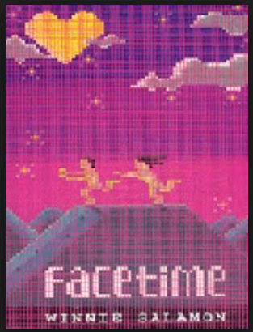

<__block>

The story, *Facetime*, is mainly aimed at ?  
[A] a teenage audience  
[B] readers of romance  
[C] parents of teenagers  
[D] readers interested in technology

<__block>

[A]

<__block>

From the information in the review, the main theme of the book is ?  
[A] using chat room responsibly  
[B] coping with people with no taste  
[C] surviving living with friends  
[D] the search for true love

<__block>

[D]

<__block>

The heavy use of jargon and slang suggests that the book ?  
[A] is of low literary quality  
[B] is intended to have movie potential  
[C] is well researched  
[D] has a shallow plotline

<__block>

[C]

<__block>

The reviewer's response to the story is ?  
[A] enthusiastic and credible  
[B] restrained but positive  
[C] tentative and improving  
[D] glowing but with a warning

<__block>

[A]

<__block>

The cover graphic suggests that *Facetime* is actually ?  
[A] an adventure program  
[B] a successful dating program  
[C] a DVD movie  
[D] an advertisement for a dance studio

<__block>

[B]

<__block>

The book cover is pixelated (made up of dots) suggesting it represents a ?  
[A] grainy photo  
[B] crude animation  
[C] computer screen  
[D] newspaper reproduction enlargement

<__block>

[C]

<__block>

What is the result of Esmerelda’s chat-room experience ?

[A]Ned decides to leave the flat

[B] Charlotte has an argument with Esmerelda

[C] Ned moves into the flat with Charlotte and Esmerelda

[D]Jack decides to fly from America to meet Esmerelda

<__block>

[D]

<__block>

The last sentence suggests that the reviewer ?  
[A] has a small office  
[B] has kept her love of technology secret  
[C] is opposed to the use of *Facetime*  
[D] has used *Facetime* to find romance

<__block>

[B]

<__block>

How does the writer describe Ned , a hard core geek ?

[A]someone who takes himself way too seriously

[B] wears flannies and Linux T-shirts and has no sense of style

[C] likes chat rooms, gnomes and b-grade movies

[D] sings to ‘99 Luftballons’ or ‘Electric Dreams’

<__block>

[B]

<__block>

Who suggested Eserelda try internet chat rooms ?  
[A] Charlotte  
[B] Sally Murphy  
[C] Ned  
[D] Jack

<__block>

[C]

<__question>

**Tying a knot**

There are a number of ways to tie a tie. To many of us there seems to be a little difference (except for the bow tie!). For the expert the differences are important.

*Types of tie knots*

Windsor, Half Windsor, Small knot, Four-in-hand, Prince Albert and Bow tie are the names of the common tie knots,

The Windsor knot, incorrectly named after the Duke of Windsor, is a wide triangular knot that is preferred by business executives.  
This knot looks smartest worn with a shirt collar that is considerably cut-away. Most students prefer the Small Knot.

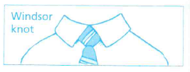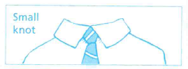

*For the best results*  
1- Drape the tie around your raised collar with the wider end extending about 30 cm below the narrow end; cross it over.



2- Wrap the wide end around and bring it up over and through the loop between the collar and the tie. Gently pull it down towards the front.



3- Curl the wide end that is left behind the narrow end.



4- Bring the wide end back up again through the loop.



5-  Put down thorough the loop and pull around across the narrow end as shown.



6- Bring the wide end up and tuck it through the loop a third time, and bring it back down to the front.



7- Finally, pull down on the end carefully to tighten and draw up the knot snugly into your collar.

8- If both ends don’t meet perfectly, simply start over and adjust the length of the tie accordingly. Make sure your collar sits nicely and centre the knot precisely.

A very common mistake many school students make once they get the first knot done correctly is that they are reluctant to untie the tie at the end of the school day. They prefer to make the loop just big enough to pull their head out and hang the tied tie on the back of a chair. Unfortunately, that is the most damaging (and disrespectful) thing to do to a tie.

There is a second end-of-the-day student mistake. It is to simply rip the tie off the moment the student gets out the school gate!

The clip-on tie is one which is permanently tied. It is fixed to the front of the shirt collar ny a metal clip. The clip-on tie was reportedly invented in 1928. Maybe this is the best solution for school students!

Sources : htttp//www.brooksbrothers.com/tieknots/smallnot.tem

http//www.tieanecktie.com/WindsorKnot.php

<__block>

The instructions for tying a tie using a Windsor knot would be used most often by ?  
[A] school students  
[B] professional people  
[C] descendants of the Duke of Windsor  
[D] the British peerage

<__block>

[B]

<__block>

The instructions suggest that the writer is ?  
[A] extremely careful and precise  
[B] easily upset and flippant  
[C] showy and attention seeking  
[D] sophisticated and dismissive

<__block>

[A]

<__block>

Which line best suggests that the writer despises sloppy tie tiers ?  
[A] Make sure your collar sits nicely  
[B] The Windsor knot is a wide triangular knot that is preferred for formal occasions  
[C] Maybe this is the best solution for school students  
[D] There are a number of ways to tie a tie

<__block>

[C]

<__block>

The writer implies that the type of tie knot should ?  
[A] be changed regularity  
[B] vary for particular situations  
[C] reflect the type of person one is  
[D] be suited to the collar design

<__block>

[D]

<__block>

After looping the tie the second time, the next step is to ?  
[A] adjust the length of the narrow end  
[B] pull the wide end across the narrow end  
[C] Open the loop to let the narrow end slip through  
[D] tighten this section of the knot before proceeding

<__block>

[B]

<__block>

Most of the action in tying a tie is ?  
[A] based on the manipulation of the wide end  
[B] adjusting one end, then the other end  
[C] keeping all loop tight as the knotting progresses  
[D] making sure the narrow end is shorter than the wide end

<__block>

[A]

<__block>

Based on his knowledge and attitude towards school children, the writer suggests ?

[A] they shouldn't have to wear ties

[B] removing the school tie by looping it over the head

[C] it would be better if they had clip-on ties

[D] using a Windsor knot rather than a Small knot

<__block>

[C]

<__question>

**Euthanasia – what do you think?**

You don't get topics hotter than this one and the *Advocate* letters page is the place where you can express your opinion on such issues.

Some people believe euthanasia is one of those slippery slopes just too steep to consider.

Where do you draw the line? How can you be sure that the person is of ‘sound mind’? And so the questions go.

Churches have traditionally been against it, saying life is a precious gift and must be preserved.

Others, like the vocal advocate, Dr Phillip Nitschke, believe people should be able to die with dignity when they are ready.

Great Lakes resident Lesley Archer is also of that opinion, "A peaceful death is everyone's right," she said.

She will convene a public meeting on the issue next Wednesday at 10:30 am at the Coastal Patrol Headquarters, Forster Breakwater.

If there is enough interest at the meeting, Dr Nitschke himself has said he will visit Forster to conduct a workshop sometime later in the year.

There is no doubt he is dicing with the law but he's no stranger to that.

So what do you think?

Why not write us a letter to share your views? This page is for you.

Janine Watson

From The Great lakes Advocate, 14/05/08

<__block>

According to the editorial, the paper is ?  
[A] supporting euthanasia  
[B] supporting euthanasia in special circumstances  
[C] encouraging debate on the issue of euthanasia  
[D] opposed to euthanasia

<__block>

[C]

<__block>

What argument does the paper put forward against euthanasia ?  
[A] it is a much too difficult subject to consider  
[B] No-one can be sure a person accepting euthanasia is of ‘sound mind’  
[C] The churches are opposed to euthanasia  
[D] Dr. Phillip Nitschke has a criminal record

<__block>

[B]

<__block>

The editor says that Dr. Phillip Nitchke is ‘dicing with the law’.

By this, she is implying Dr.  Nitschke is ?  
[A] challenging the law on euthanasia issues  
[B] treating the matter as a game of life and death  
[C] taking a gamble on not getting caught  
[D] breaking the law by attending the meeting

<__block>

[A]

<__block>

The editor describes euthanasia as a ‘hot topic. By this, she means ?  
[A] the paper will get a lot of letters of complaint  
[B] euthanasia is a topic that creates heated public debate  
[C] the press at the newspaper will run hot printing letters  
[D] many people will change their opinions about the subject after the meeting

<__block>

[B]

<__block>

What argument is implied in the editorial for attending the euthanasia meeting? By attending the meeting people will ?

[A] be able to show their support for Dr. Phillip Nitschke

[B] write informed letters to the *Great Lakes Advocate*

[C] learn how to have a peaceful death, as istheir right

[D] be better informed on the euthanasia issue

<__block>

[D]